Book Store

And

Management System

In

Software Engineer

**Chapter 1. Tools used in the Development**

The tool I used to build a system is **Python Language**. And the one I used in the system database is **XAMPP Server.**

What is Python Language? Is an interpreted, high level and general-purpose programming language. Python’s design philosophy emphasizes code readability with its notable use of significant whitespace.

What is XAMPP Server? Is a free and open source cross platform web server solution stack package developed by Apache Friends, consisting mainly of the Apache HTTP Server, MariaDB database, and interpreters for scripts written in the PHP and Perl programming.

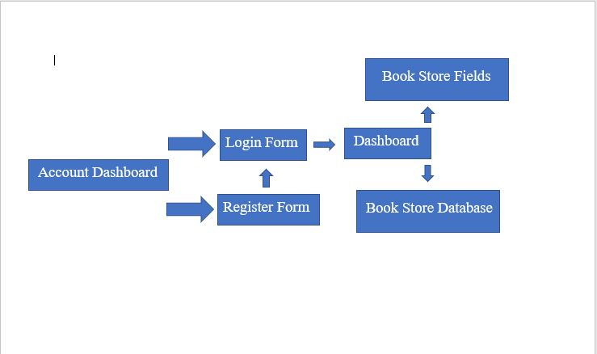**Chapter 2. Process Flow Diagram**

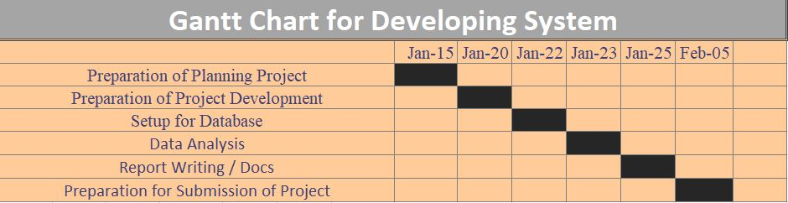**Chapter 3. Time Table (Gant Chart)**

**Chapter 4. Cost of Analysis**

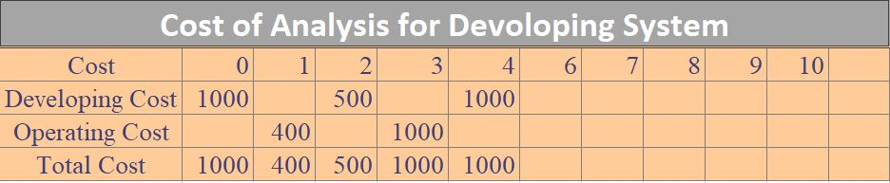

**Chapter 5. Platform uses in the Development**

I used to build a system is Visual Studio Code. So why visual studio code? It because free source codes editor made by Microsoft for **Windows**, **Linux**, and **MacOS**. Features include

support for debugging, syntax highlighting intelligent code completion, snippets, code refactoring and embedded Git.

**Chapter 6. Manual of the Procedure (How the System Works.)**

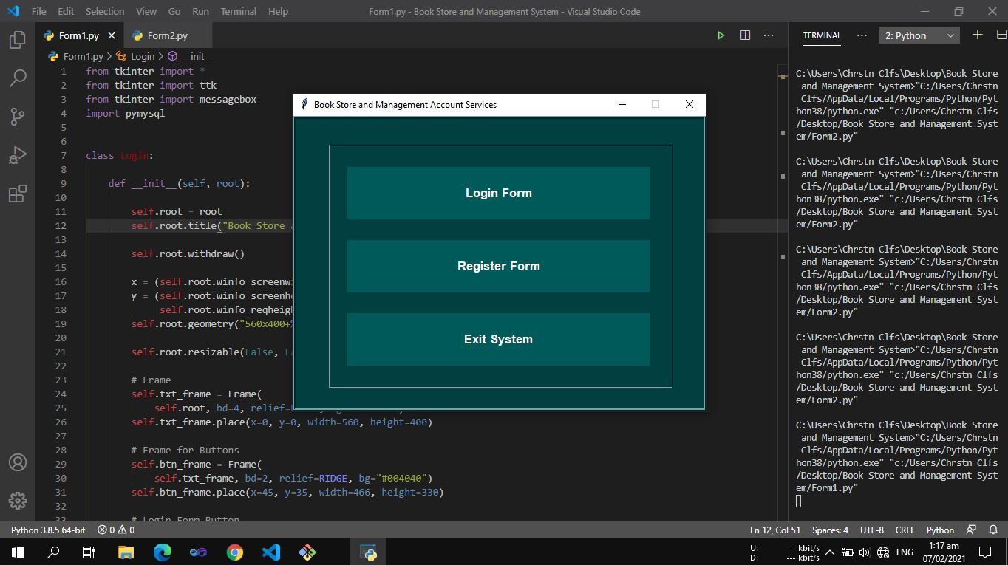1. First click on the login form in the dashboard

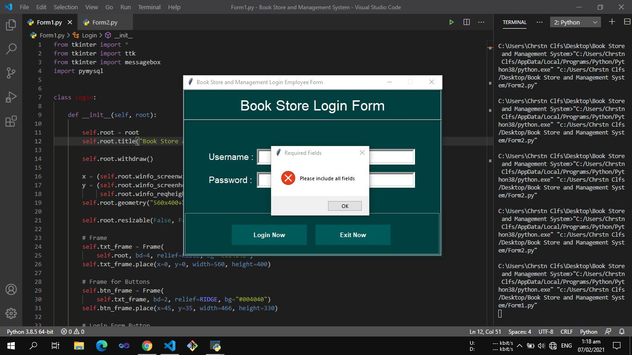2. Now you need to register in order to Login and fill up the fields

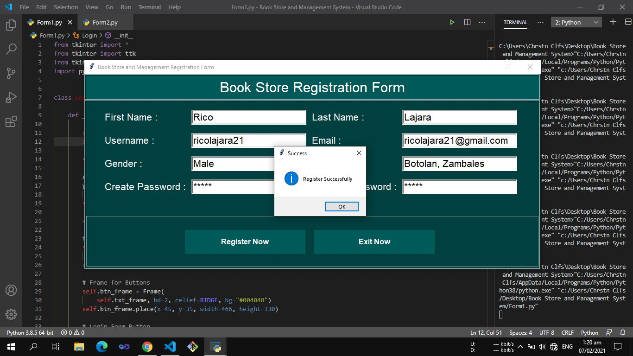3. Register Form now you need to fill up all this fields.

4. and Go back to Login form and input your username and password.

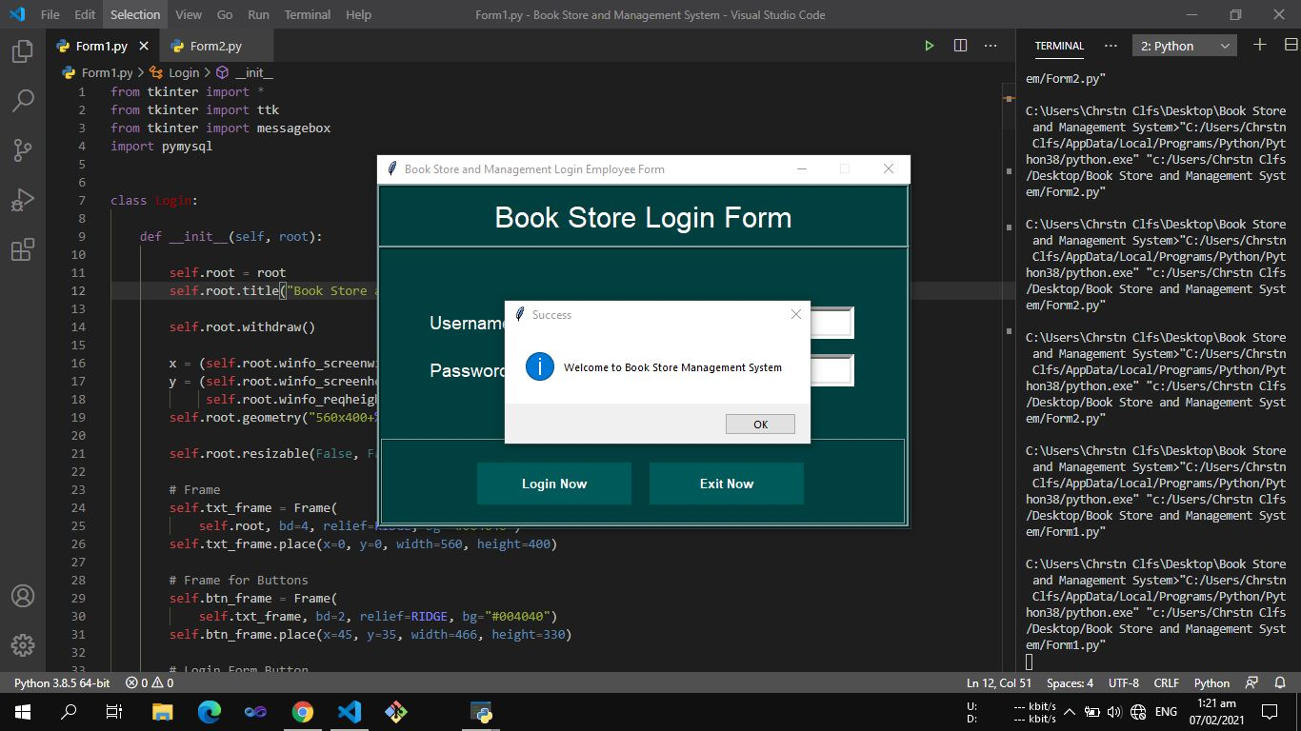

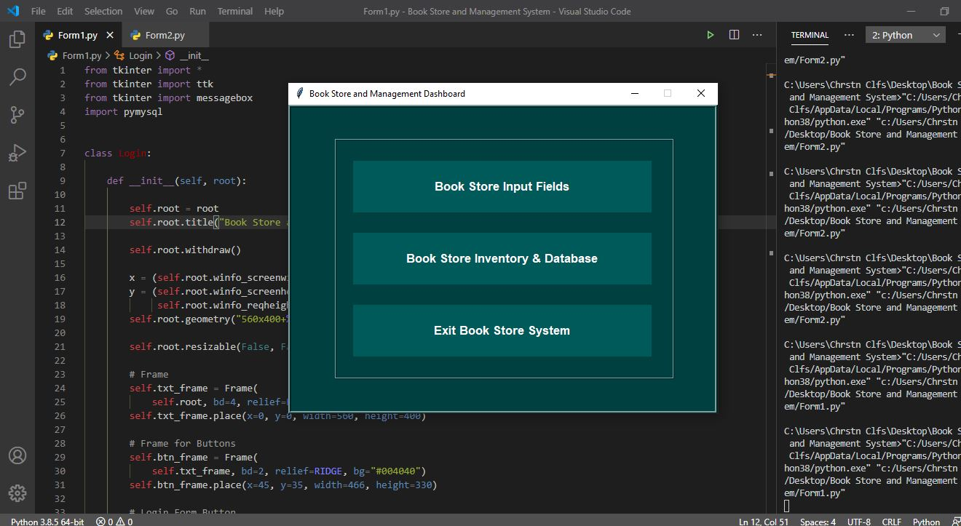5. And Click the Book Store Input Fields

6. Book Store Input Fields, now you’re in, you must fill up what product/item you need to buy and adding to your inventory list.

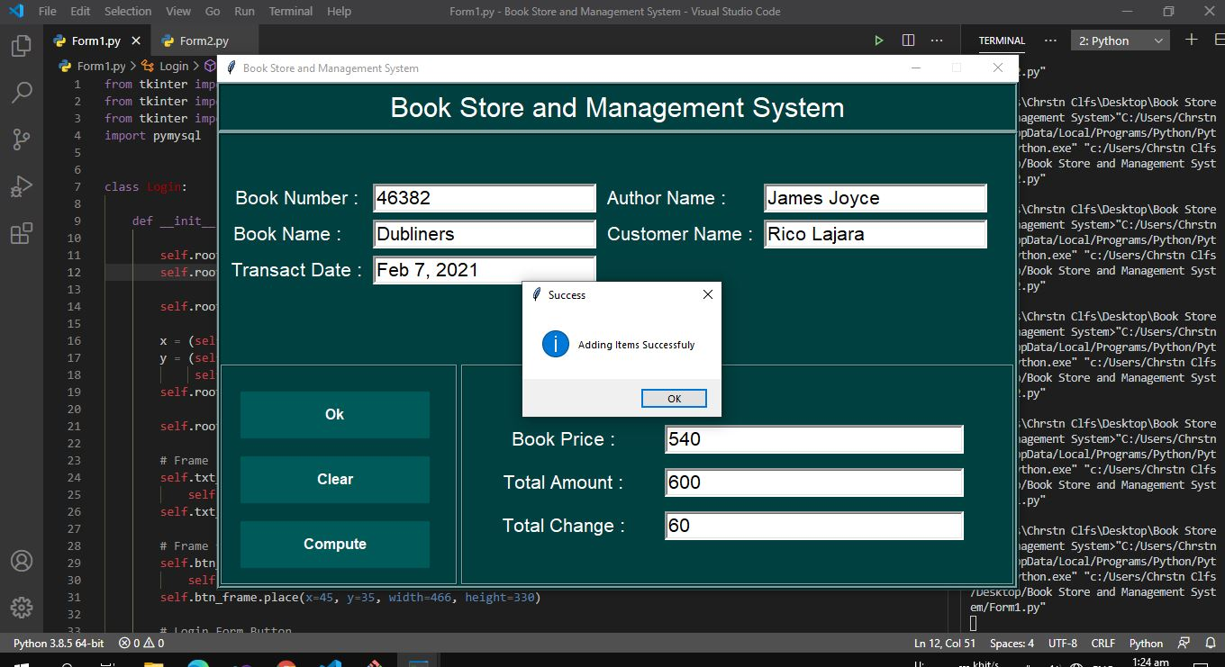

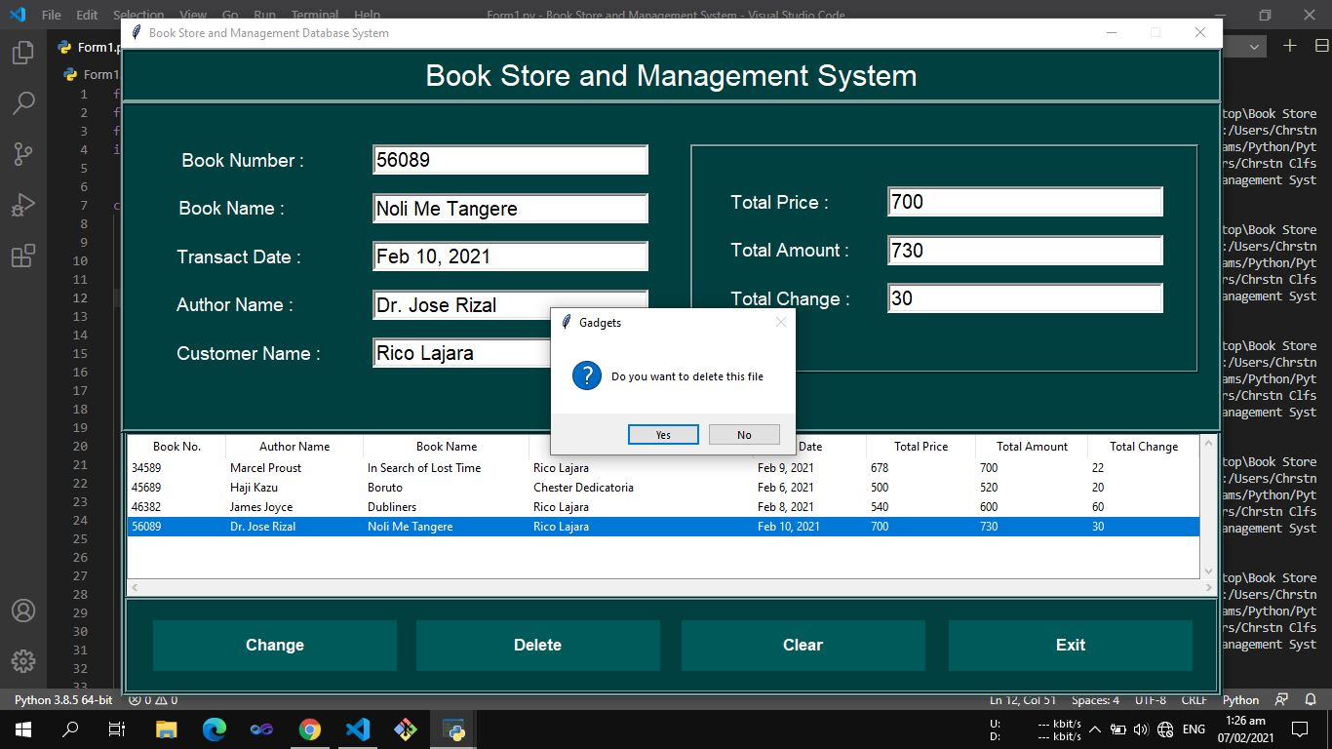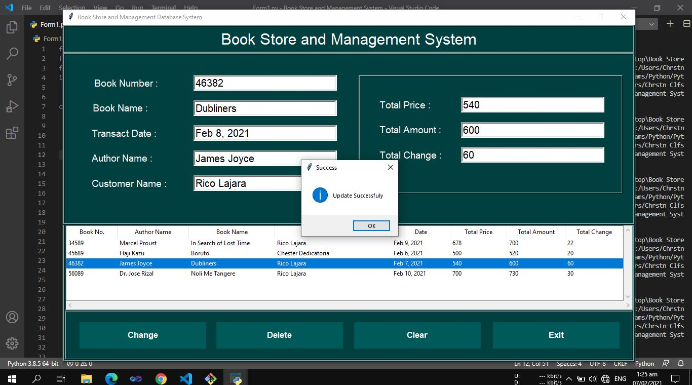7. Book Store and Inventory Database, you can delete other in the list inventory that you haven’t no longer needed Once you've deleted an item, it will no longer display on the inventory list. You won't be able to select this item when you're adding or editing a transaction, quote or purchase order.

**Group Member:**

* Rico Lajara
* Chester Dedicatoria